**Hack to Crack 2.0: Event Report**

**1. Introduction**

Hack to Crack 2.0, a national-level 36-hour hackathon, was organized on March 20-21, 2025, at Vishwaniketan's Institute of Management, Entrepreneurship, and Engineering Technology (iMEET) by Department of CSE(AI&ML) in Mumbai Maharashtra. This edition brought together the brightest minds from across the country to collaborate, innovate, and solve real-world problems. With cutting-edge projects and groundbreaking solutions, Hack to Crack 2.0 showcased the future of technology.

The event saw enthusiastic participation from over 400 participants across 100 selected teams, representing more than 7 states, including Karnataka, Rajasthan, Uttar Pradesh, Tamil Nadu, Andhra Pradesh, Madhya Pradesh, and Maharashtra. With participants from 50+ colleges across 25+ cities, Hack to Crack 2.0 achieved remarkable success. Boasting a total reach of 82.2K and over 950+ registrations from 300+ colleges, the event surpassed expectations, fostering innovation and driving technological progress.

**2. Objectives**

The key objectives of Hack to Crack 2.0 were:

* Innovation: Encourage students to solve real-world problems through technology.
* Collaboration: Provide a platform for participants to network, exchange ideas, and collaborate.
* Industry Exposure: Connect students with mentors, industry experts, and corporate leaders.
* Learning: Offer hands-on experience in problem-solving and coding under pressure.
* Recognition: Reward outstanding solutions through awards, internships, and incubation opportunities.

**3. Event Overview**

* Event Name: Hack to Crack 2.0
* Date: March 20-21, 2025
* Duration: 36 Hours
* Venue: Vishwaniketan iMEET, Mumbai Maharashtra
* Participants: 400+
* Total Teams: 100+
* Colleges Represented Offline: 50+
* State Represented: 7+
* Cities Covered: 25+
* Total Reach: 82.2K
* Total Registrations: 952 Participant
* Selected Teams: 100+
* Tracks:
  + AI/ML
  + Web3 & Blockchain
  + Sustainability
  + EdTech
  + Student Innovation
  + Healthcare

**4. Organizing Team**  
Hack to Crack 2.0 was meticulously organized by the dedicated student association of the Department of Computer Science and Engineering (Artificial Intelligence & Machine Learning). The association, comprising passionate and enthusiastic students, played a pivotal role in planning, coordinating, and executing the event. From conceptualizing the hackathon's theme and managing logistics to collaborating with sponsors and facilitating participant engagement, the organizing team ensured a seamless experience.

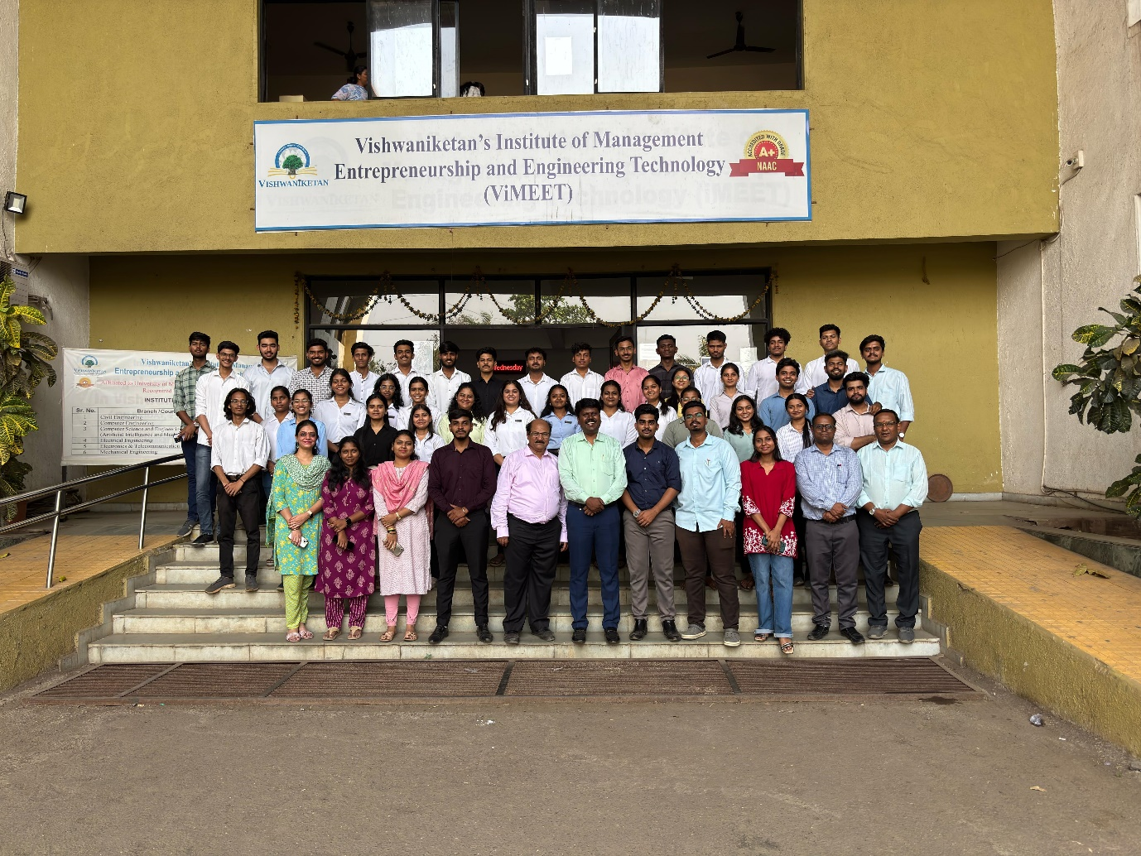

Fig 1: Hack To Crack 2.0 Organising committee

**5. Event Phases**

5.1. Planning Phase

The planning phase commenced six months prior to the event. It involved:

* Defining problem statements in collaboration with industry experts.
* Securing sponsorships and partnerships.
* Designing the hackathon format and tracks.
* Recruiting judges and mentors.
* Promoting the event through various channels.

5.2. Registration Phase

The registration opened on 21st January 2025, attracting entries from across the country. Participants registered through our platform partner unstop. The selection was based on:

* Problem-Solving Skills
* Innovation Potential
* Technical Knowledge
* Team Collaboration

Out of 363 teams applications, 100 teams were shortlisted to participate.

5.3. Hackathon Phase

The Hackathon commenced on March 20, 2025, with an inspiring inaugural ceremony. We were honored to have **Mr. Rajesh Bapusaheb Chougule,** a visionary leader and social entrepreneur, as the Chief Guest. As the Founder and Managing Director of multiple companies and a dedicated advocate for social welfare, his presence added immense value to the event.

**Dr. Munir Sayyad**, Vice President at Reliance Jio and leader of the 5G/6G & AI Innovation Labs, graced the occasion as the Guest of Honour. With 25 years of experience, 6 international patents, and numerous publications, Dr. Sayyad's insights further enriched the event.

Following the inauguration, participants enthusiastically moved to their workstations, ready to take on the 36-hour challenge and bring their innovative solutions to life.

* Mentoring Sessions: Industry mentors provided valuable guidance.
* Networking Opportunities: Participants connected with industry leaders.

5.4. Evaluation Phase

The projects were evaluated based on:

* Innovation
* Technical Complexity
* Functionality
* User Experience
* Impact and Feasibility
* Presentation and Demo

A panel of experienced judges from academia and industry selected the winners.

*Panel 1: AI & ML*

Dr. Sunil Mane (COEP Pune)

Mr. Vikas Gaikwad (VP, Citi Bank)

*Panel 2: Student Innovation*

Dr. Madhav Chandane (VJTI)

Dr. Gopal Upadhye (VIT Pune)

*Panel 3: EdTech*

Mr. Gaurav Patil (Tech Mahindra)

Dr. Vikrant Agaskar (Vidyavardhini, Vasai)

*Panel 4: Healthcare*

Dr. Jinesh Melvin (Pillai College)

Mr. Pankaj Suryawanshi (TCS)

*Panel 5: Sustainability & Blockchain*

Dr Subhash Pingale

Mr Vikas Thombre

5.5 Valedictory session

The Valedictory Session of Hack to Crack 2.0 was honored by the presence of Dr. Sandeep Joshi, Principal of Pillai College of Engineering, Panvel, as the Chief Guest, along with Dr. Sandip Inamdar, Vice President of Vishwaniketan. Their inspiring words encouraged participants to pursue innovation and excellence. Dr. Joshi commended the creativity and dedication displayed by the teams, while Dr. Inamdar provided valuable guidance, making the session a memorable conclusion to the event.

**6. Sponsors and Partners**

Hack to Crack 2.0 was supported by leading companies and organizations.

* Sponsors:
  + Aptech
  + Markscape
  + RCF Chemicals
  + RKDemy
  + 0x Day
  + IIIT PRO

**7. Track Overview and Problem Statements**

**Artificial Intelligence & Machine Learning (AI/ML):**

* Develop a chatbot for mental health support that can identify user emotions and provide supportive responses based on a predefined knowledge base. (AI/ML001)
* Build an AI-powered recommendation system for farmers to select optimal crops based on soil type, weather conditions, and market demand. (AI/ML002)
* Design a machine learning model to predict and mitigate the risk of natural disasters like floods, earthquakes, or wildfires using satellite imagery and sensor data. (AI/ML003)

**Web3 and Blockchain:**

* Create a blockchain-based voting system to ensure secure, transparent, and tamper-proof elections. (W/B001)
* Develop a decentralized platform for tracking the supply chain of medicines to combat counterfeit drugs.  (W/B002)
* Implement a smart contract-based solution for dynamic carbon credit trading, incentivizing industries to adopt sustainable practices. (W/B003)

**Sustainability:**

* Design a WebApp that helps users calculate their daily carbon footprint and provides tips for reducing it. (SS001)
* Build a platform that connects local communities with excess food to nearby NGOs or shelters to reduce food wastage.  (SS002)
* Create a real-time water quality monitoring system using IoT and AI for lakes and rivers, with actionable insights for government agencies.  (SS003)

**Education Technology (EdTech):**

* Create a gamified learning app for kids to improve their math and reading skills with interactive exercises. (ET001)
* Develop an AI-powered tool that generates personalized study plans for students based on their learning speed, preferences, and strengths. (ET002)
* Build a blockchain-based platform for issuing, verifying, and sharing academic credentials securely and globally. (ET003)

**Healthcare:**

* Develop a telemedicine platform for connecting rural patients with doctors for online consultations and prescription generation. (HC001)
* Create a system to predict and monitor early symptoms of chronic diseases  (like diabetes or hypertension) using wearable devices and AI. (HC002)
* Build a blockchain-powered electronic health record (EHR) system that  ensures data privacy and allows seamless data sharing between hospitals. (HC003)

**Student Innovation:**

* Students are welcome to bring their own problem statement but it should be solved the real world problem(Student Innovation)

**8. Winners and Awards**

1St Prize Winner

Team VisionCreators from VESIT, Mumbai, and TSEC, Mumbai, developed SmartCare, an innovative solution for paralysis patients. It uses eye tracking for quadriplegics, joysticks for monoplegics and paraplegics, and Hall effect sensors for diplegics. The system features path memorization for automated navigation and an Impulse Edge Model for real-time fall detection with instant alerts via Twilio. Additionally, it monitors vital signs like body temperature, SpO2, and heart rate, ensuring timely health responses. The team members Devendra Gawade, Jatin Vaity, Sankalp Shrivastava, and Ritik Pandey showcased remarkable innovation in the Student Innovation track.

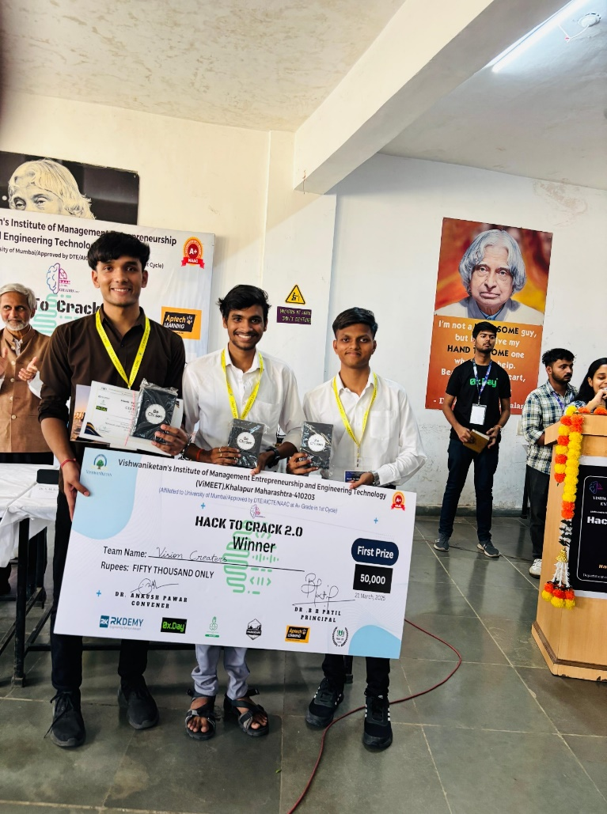

2nd Place

Team Hat Squad from Bangalore Institute of Technology (BIT), Bangalore, developed, a life-saving application designed to support pregnant women throughout their pregnancy journey. The project was inspired by a tragic incident where a woman lost her life on their premises due to an undetected fetal death. Determined to prevent such cases, the team created an app that provides real-time health monitoring, timely reminders, and essential guidance for expecting mothers. By promoting early detection of complications and ensuring access to medical support, It aims to safeguard maternal and fetal health. The team, consisting of Tejas H J, Havyas M.P, Dhanyashree U R, and Abhishek Rao K, showcased their commitment to making a meaningful impact in the Healthcare track.

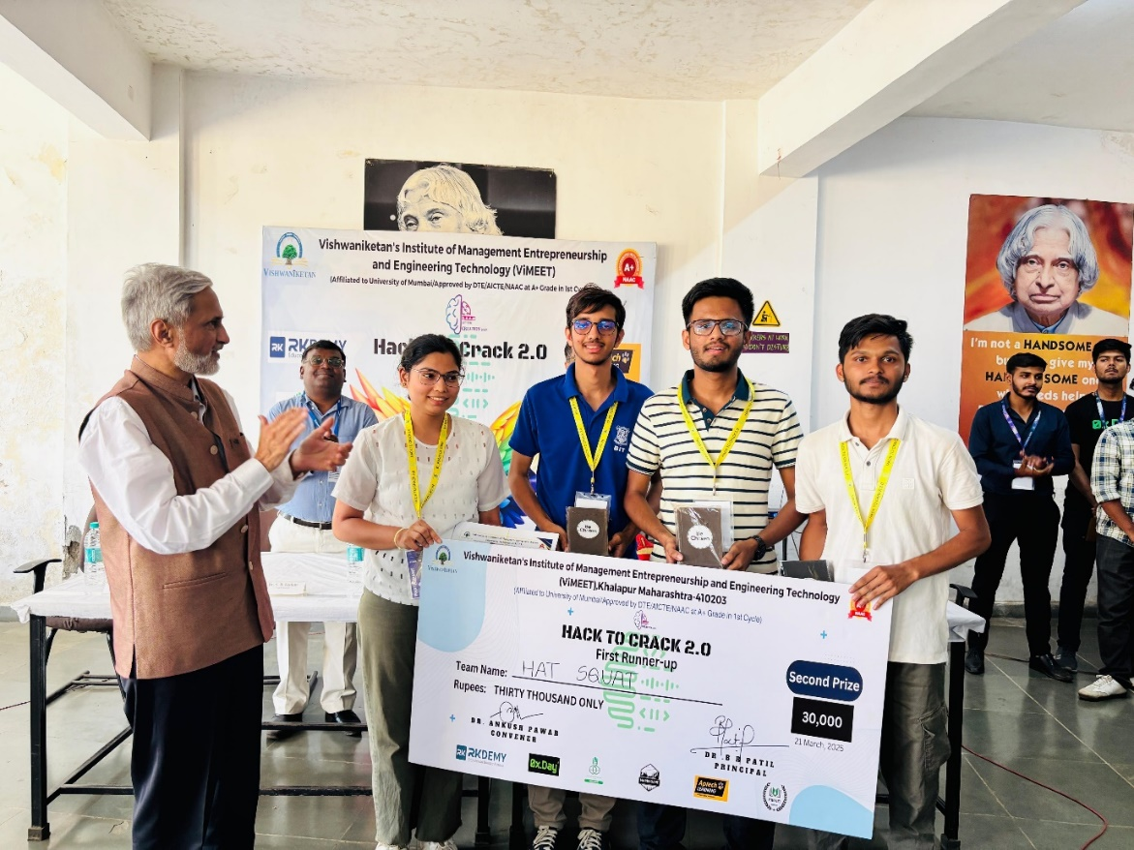

3rd Place

Team Code Artisan from PHCET, Maharashtra, developed Kalakriti, a digital platform designed to empower rural artisans by connecting them with a global audience. The platform features virtual galleries, AI-driven recommendations, and secure e-commerce to help artists showcase and sell their work.It offers skill development programs, live events, and AR-powered previews for a more immersive experience. By bridging the gap between traditional craftsmanship and modern technology, The team, comprising Soham Patil, Simran Dhole, and Aditi Pawar, demonstrated exceptional innovation in the Student Innovation track.

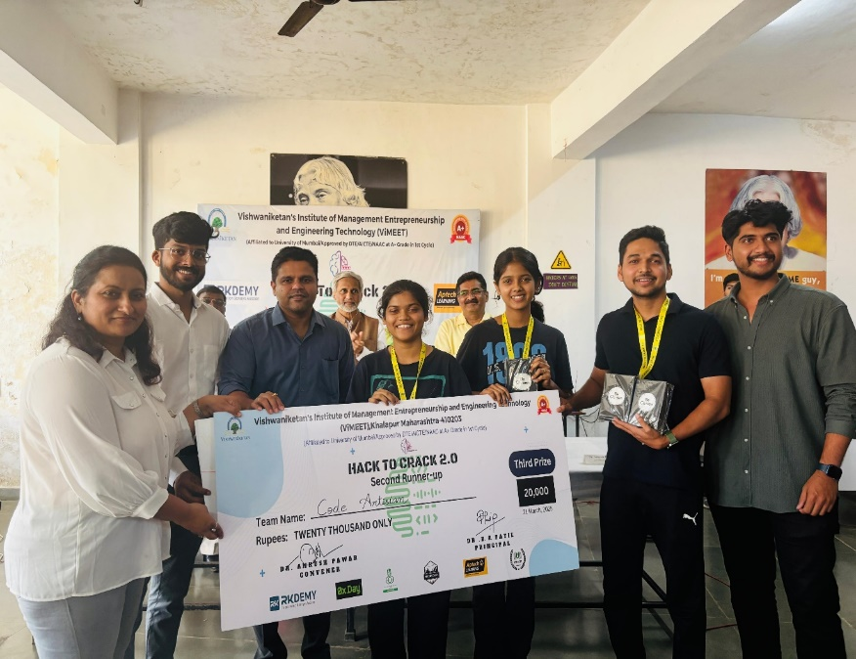

**Special Category Awards**

***Best Innovative***

Team Mahadev's created an AI-powered Smart Agriculture Recommendation System to help farmers make informed crop decisions based on soil type, weather, and market demand. Using machine learning, IoT sensor data, and predictive analytics, it maximizes yield, reduces risks, and promotes sustainable farming. The team, comprising Ayush Duseja, Sahil Ahuja, Darshan Kakad, and Vineet Chelani, won the Best Innovative Project award.

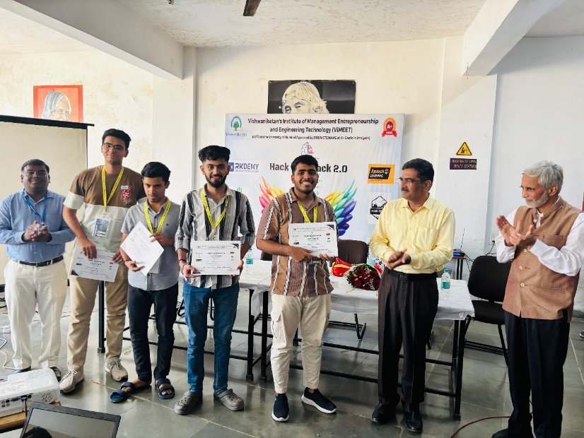

***Best UI/UX Design***

Team Hydro Verse from RGUKT Nuzvid, Andhra Pradesh, developed an intuitive and visually engaging platform to predict natural disasters and suggest effective mitigation strategies. Leveraging AI and ML, the system provides real-time insights with a user-friendly interface that ensures seamless navigation and accessibility. The clean design and interactive features offer a smooth user experience, making complex data easily understandable. The team, comprising Gopi Jagadheesh Mahamkali, Pooja Ratna Sai Sri Teku, Raghu Goddumuri, and Revathi Gugulothu, received the Best UI/UX Design award.

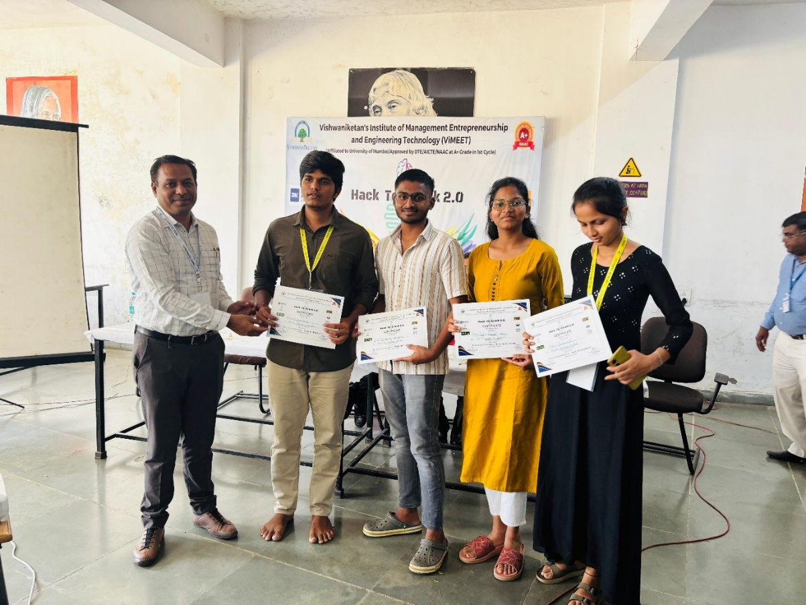

***Best Technical Implementation***

Team Tech Hunters from IIIT Dharwad developed a Web3 Carbon Credit Trading System that leverages blockchain, AI, and ML to create a secure and transparent marketplace for carbon credits. By eliminating intermediaries and ensuring verifiable offsetting, the platform promotes sustainability. Tokenized credits offer real-time accountability, while AI-driven insights help businesses make eco-friendly decisions. The team, consisting of Vishesh Dwivedi, Yashpreet Singh, and Mohana Krishnan, earned the Best Technical Implementation award.

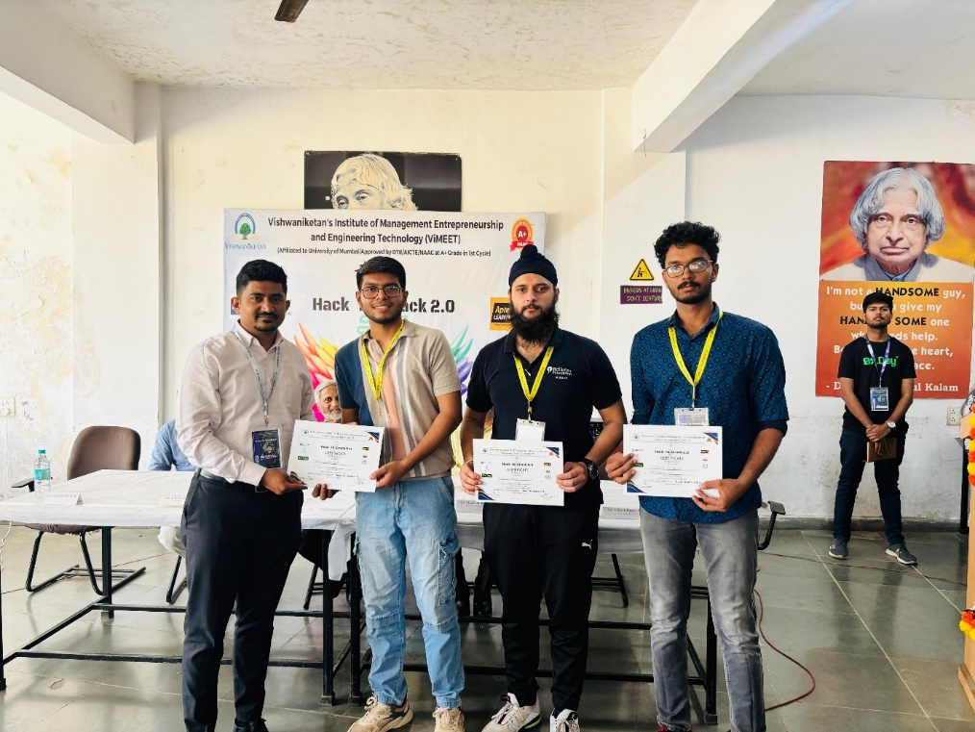

**Domain Winners**

***AI&ML***

Team 4x4 from DJSCE, Mumbai, and RAIT, Navi Mumbai, developed an Agriculture Crop Recommendation system using AI & ML. The project provided farmers with data-driven crop suggestions, promoting sustainable farming. The team members Rajat Masanagi, Devam Desai, Preitish Fondekar, and Kumar Aadarsh were awarded the Domain Winner title.

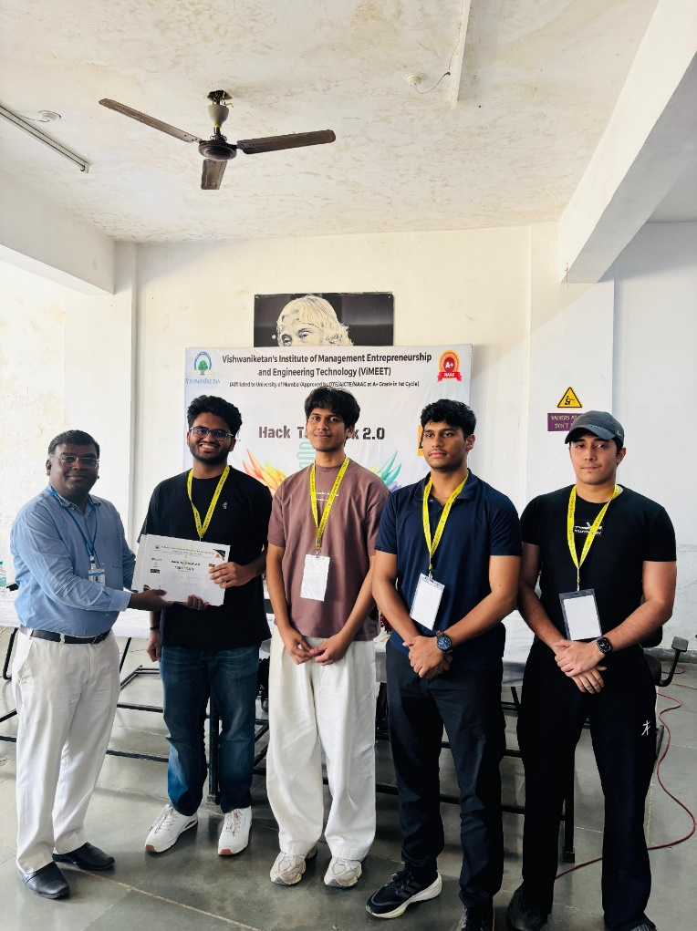

***Blockchain***

Team The Shield from CIT, Chennai, developed a Blockchain-based Voting System ensuring secure, transparent, and tamper-proof elections. By recording votes on the blockchain, the system guarantees fairness and trust. The team members Tarun T, Vishnu A, Sai Arevinth Raaj B, and Gokul Vijayanand earned the Domain Winner title.

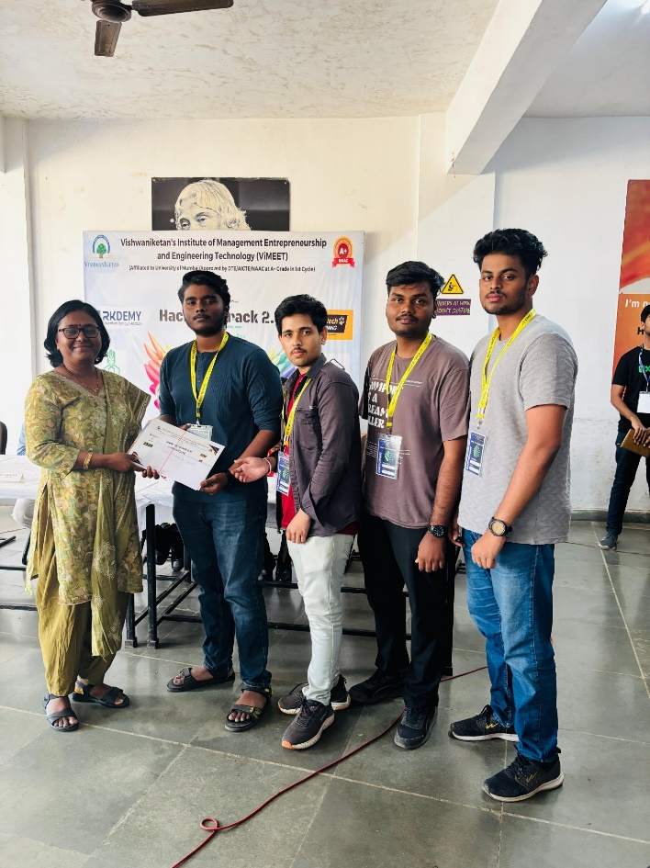

***Sustainability***

Team Galaxy from Xavier Institute of Engineering, Mumbai, developed a Food Rescue Platform using Map API to optimize rescue routes, reduce transportation costs, and maximize community benefits. By redirecting food nearing expiry to those in need, the platform promotes sustainability and reduces food waste. The team members Jayesh Chaurasia, Parth Lagishetty, Ajay Kumbhar, and Kshitij Khot earned the Domain Winner title.

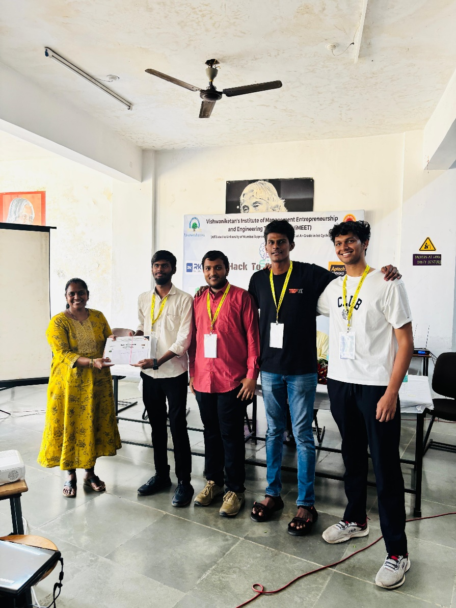

***EdTech***

Team Infinity Loop from IIIT Kota developed an Interactive Learning Platform that transforms education into an engaging adventure through gamified lessons, videos, puzzles, and real-world discovery using the Image Detective feature. A comprehensive dashboard with progress analytics and a chatbot keeps parents informed, ensuring a joyful and stress-free learning experience. The team members Anmol Upadhyay, Vikas Kumar, Sauvir Wodehra, and Adarsh Dubey earned the Domain Winner title.

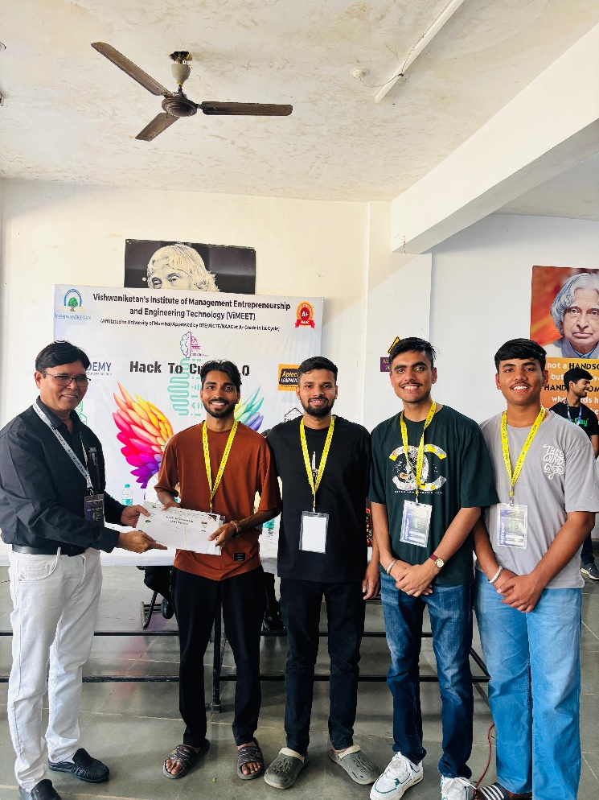

***Healthcare***

Team Code Zero from DSCE, Bengaluru, developed a Blockchain-Based Electronic Health Record System using Ethereum Sepolia in a hybrid model. Medical documents are securely stored off-chain, with hashed URLs recorded on the blockchain for enhanced security and efficient storage. The team members Sathwik Shetty, Ritvik K, Khushbu R, and Shreyas earned the Domain Winner title.

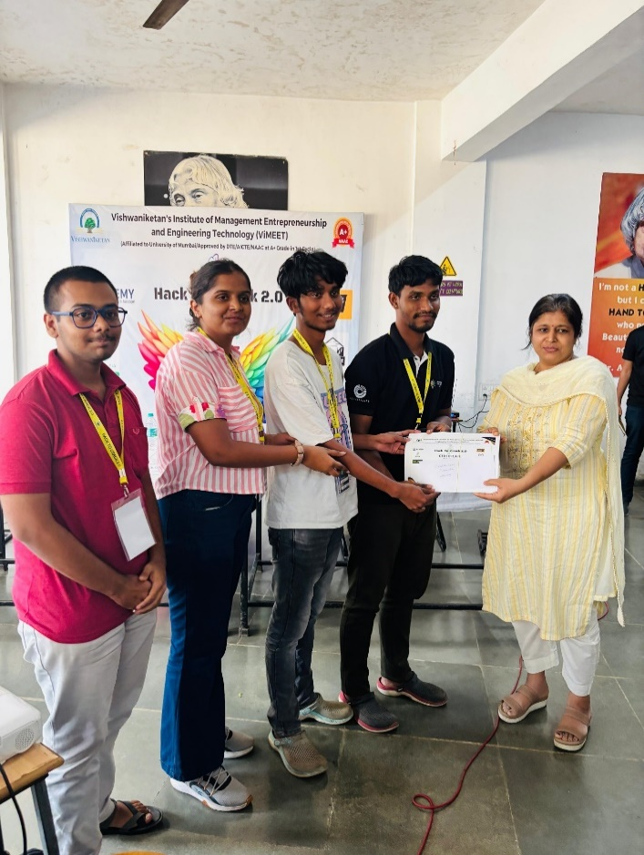

***Student Innovation***

Team NAT from TIT, Bhopal, developed a QR-Less Payment System, offering a revolutionary way to make payments and access location-based information without the need for QR codes. Designed for cafes, restaurants, businesses, and toll tax payments, the system ensures fast and seamless transactions. The team members Ayush Kumar, Raman Lodhi, Lohitaksha Rawte, and Krishna Nema earned the Domain Winner title.

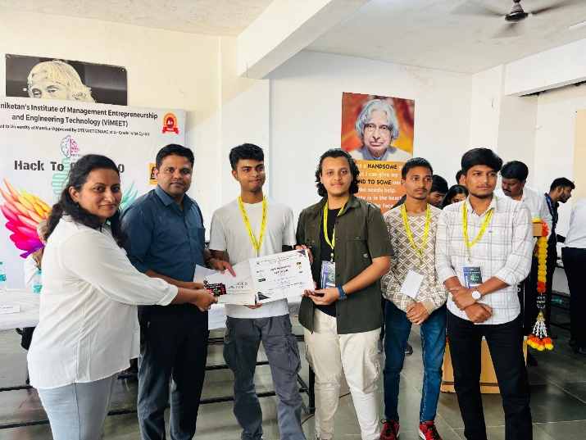

***Student Innovation Runner-Up***

Team Delta from Lokmanya Tilak College of Engineering, Navi Mumbai, developed an AI-powered Farmer Assistance Platform offering personalized scheme recommendations, real-time market insights, and voice-based support. It simplifies access to government benefits, modern farming techniques, and subsidy eligibility checks, empowering farmers to make informed decisions. The team members Ritesh Singh, Siddhesh Gupta, Raj Parihar, and Nitesh Yadav secured the Runner-Up position in the Student Innovation category.

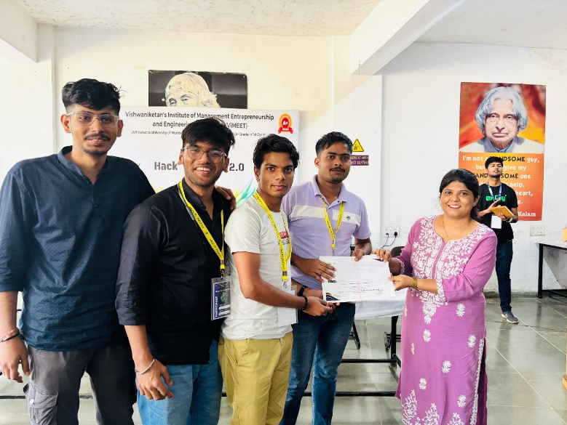

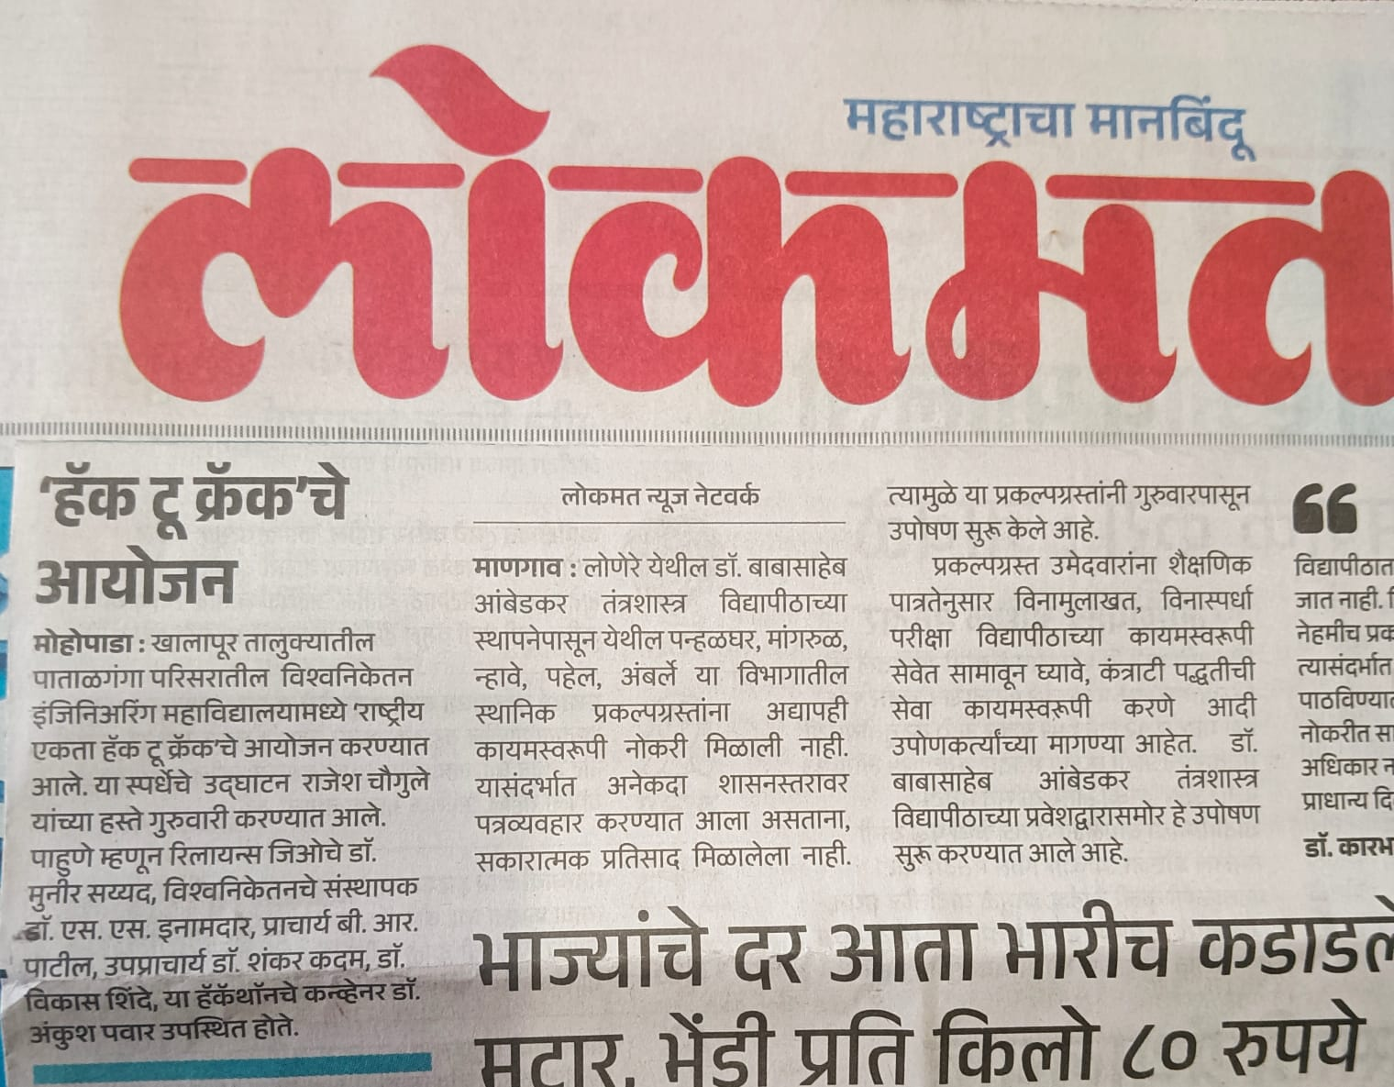9.Hack To Crack In News

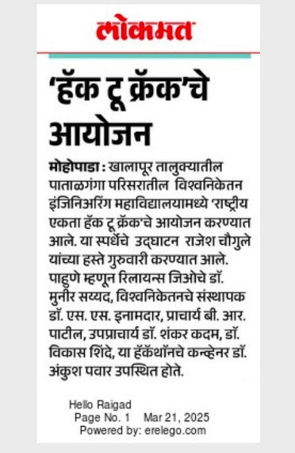

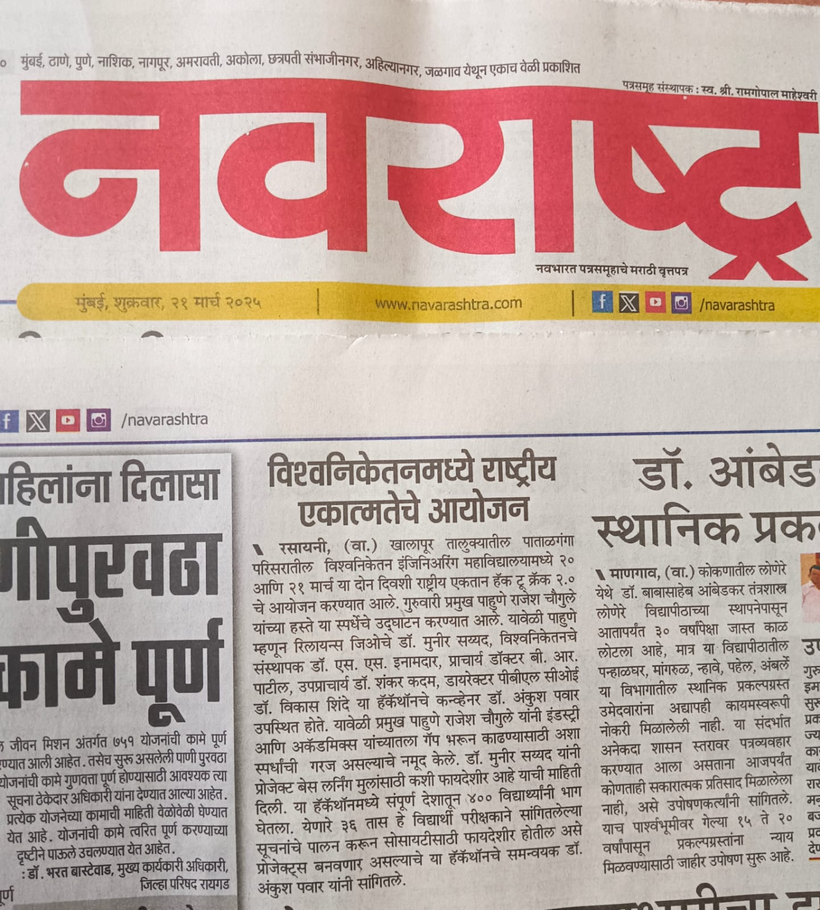

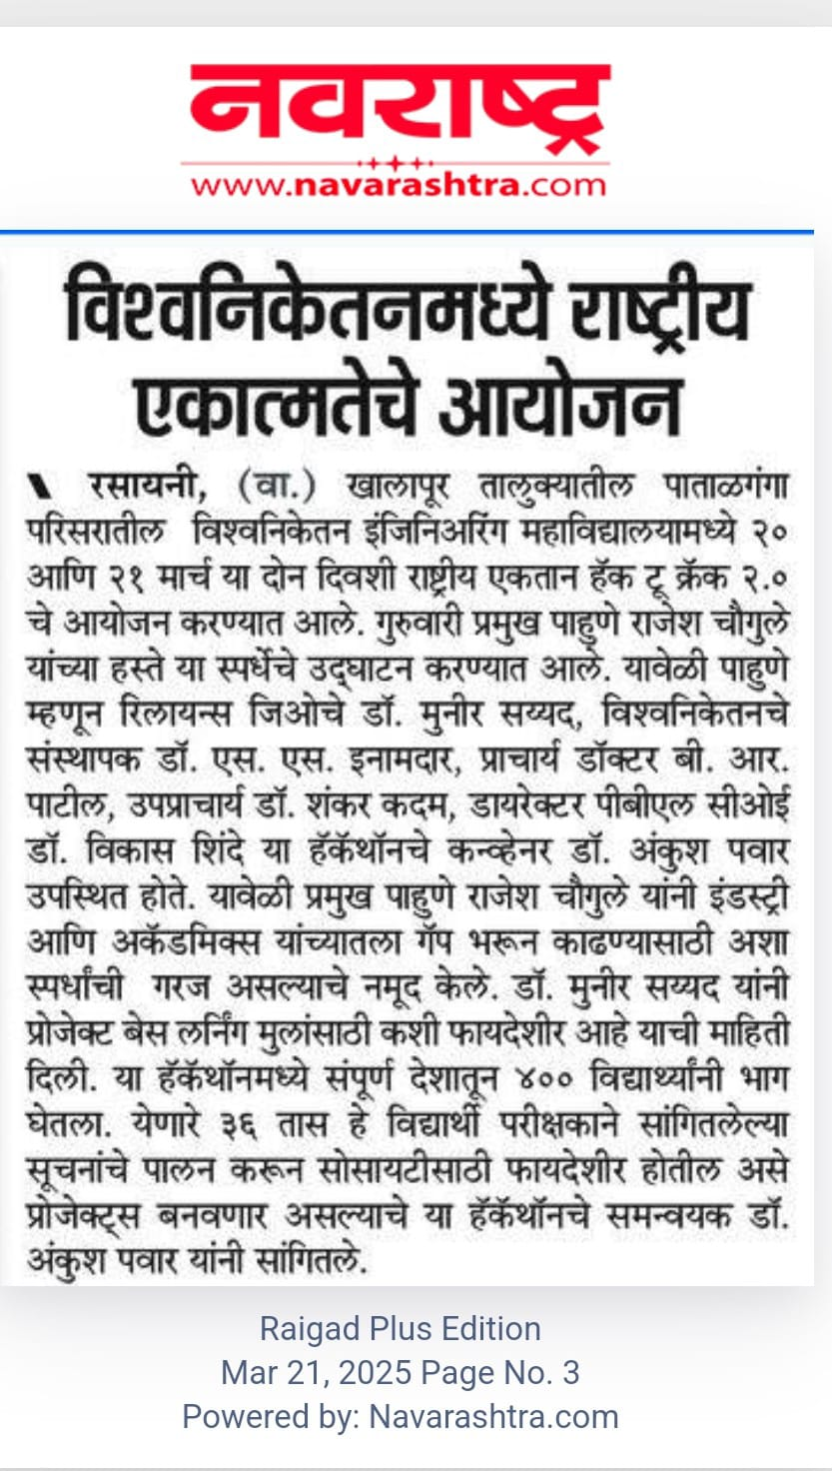

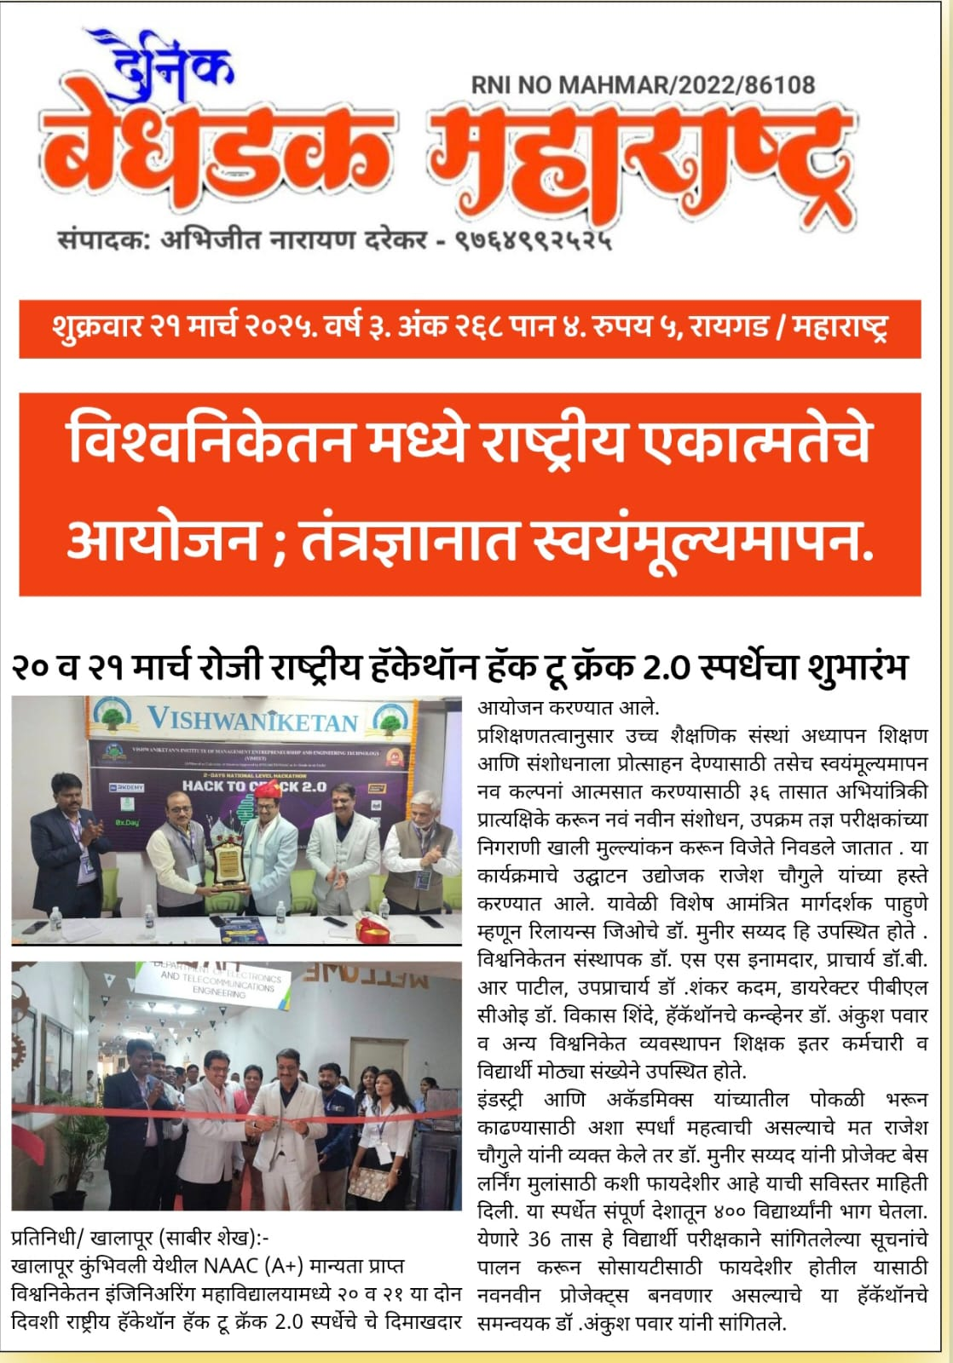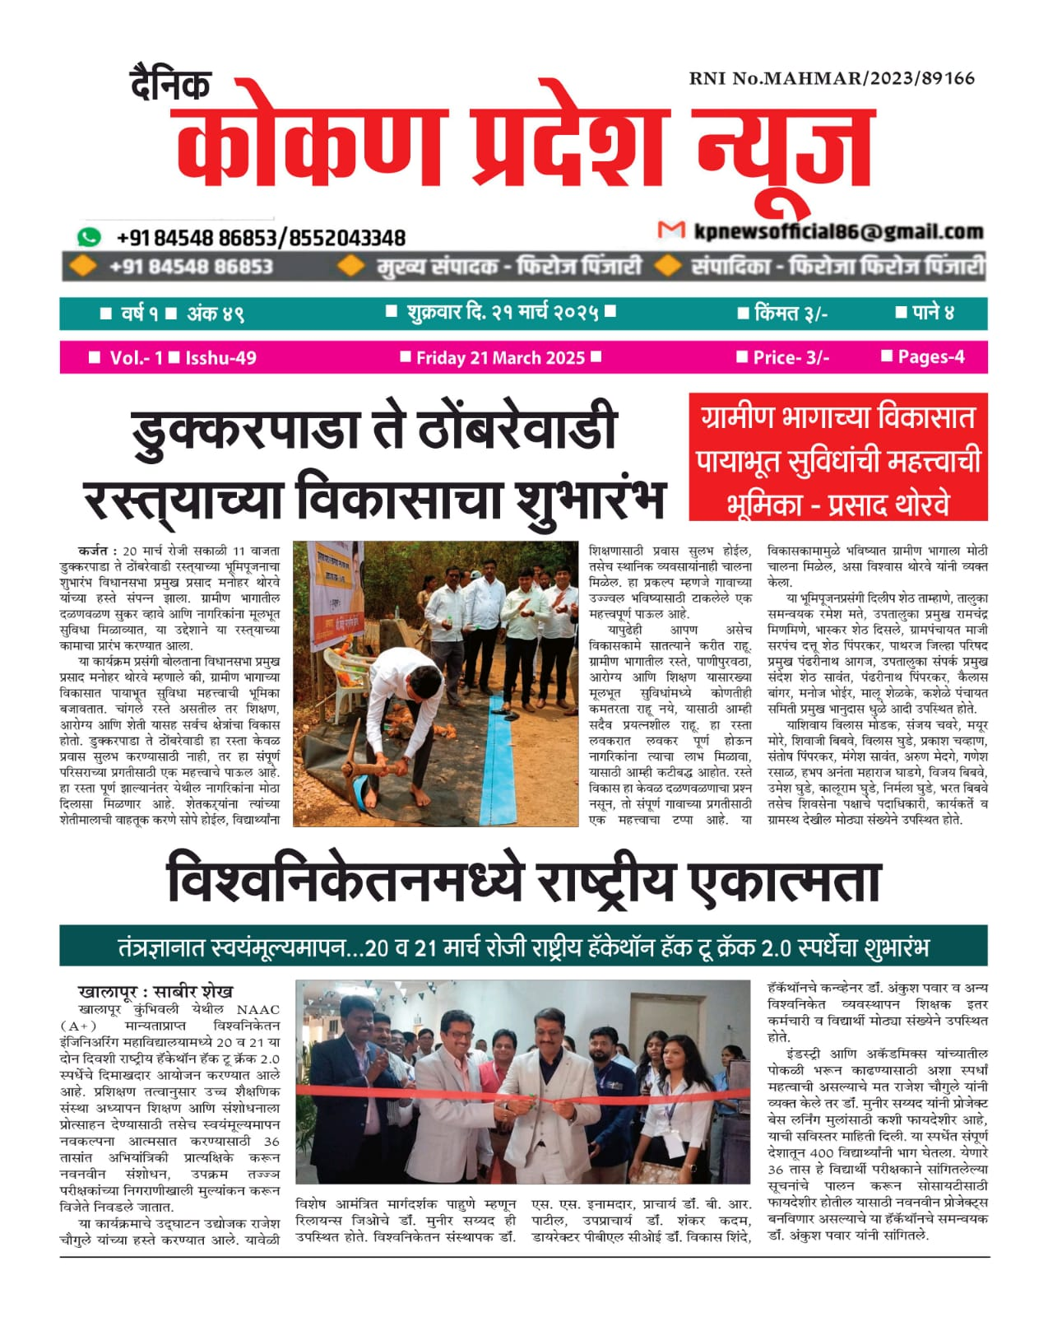

**10. Hack To Crack In Picture**

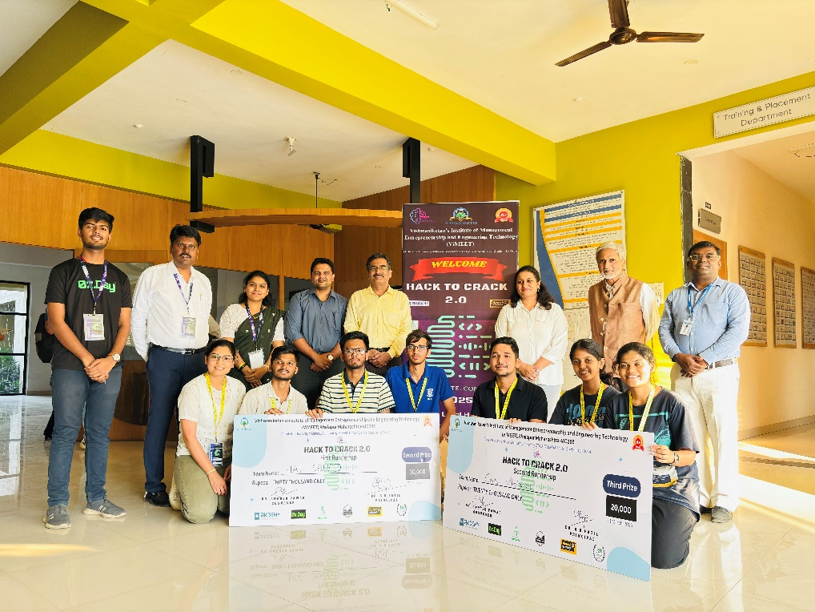  
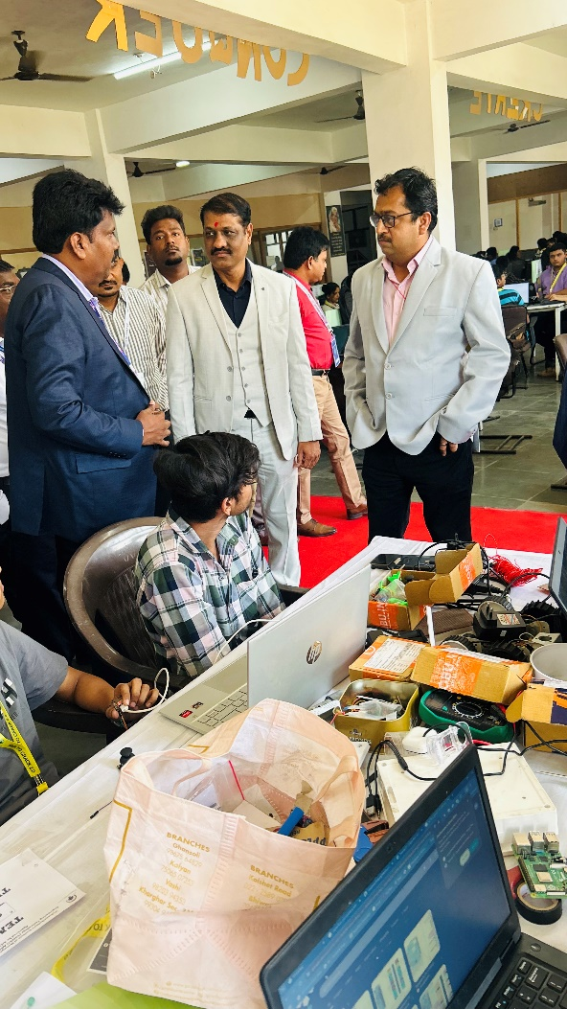

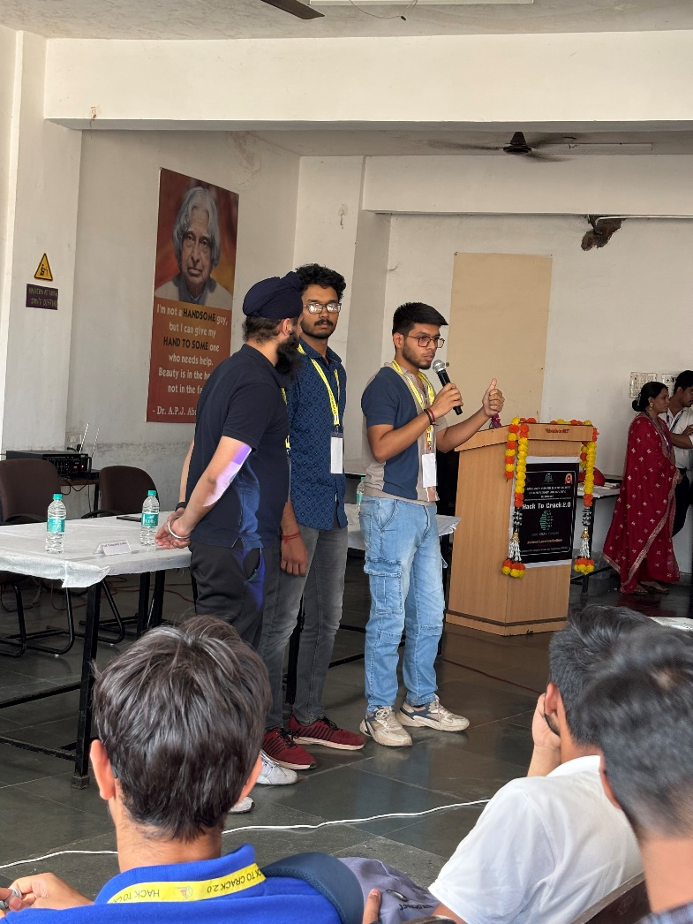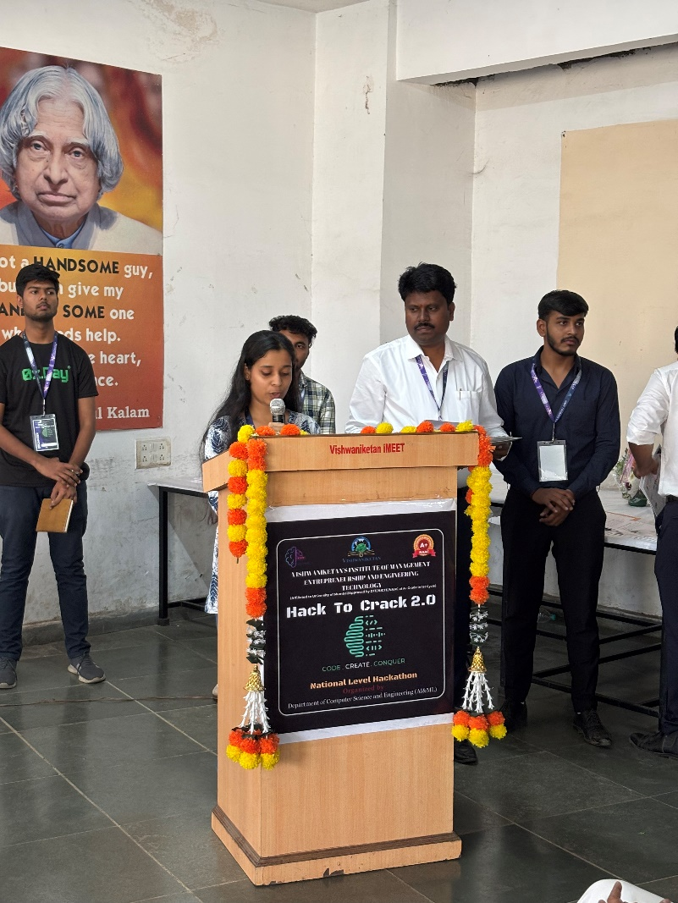

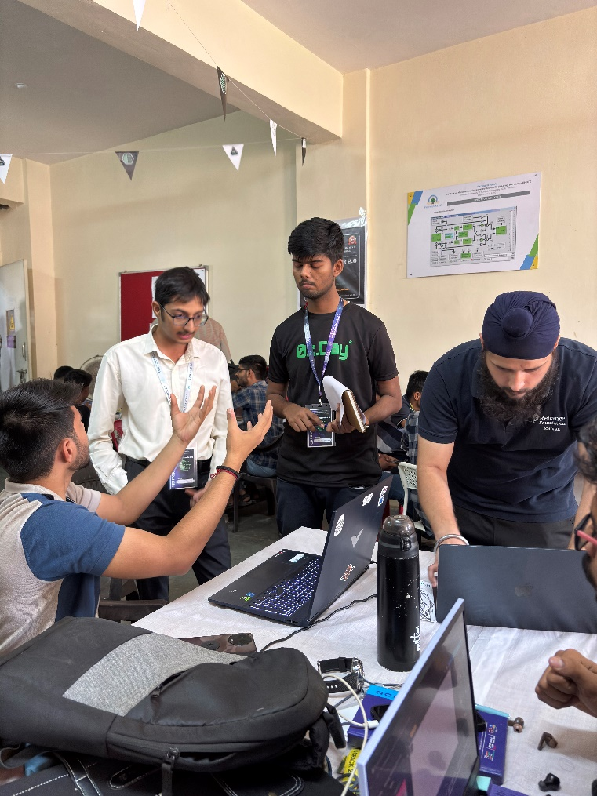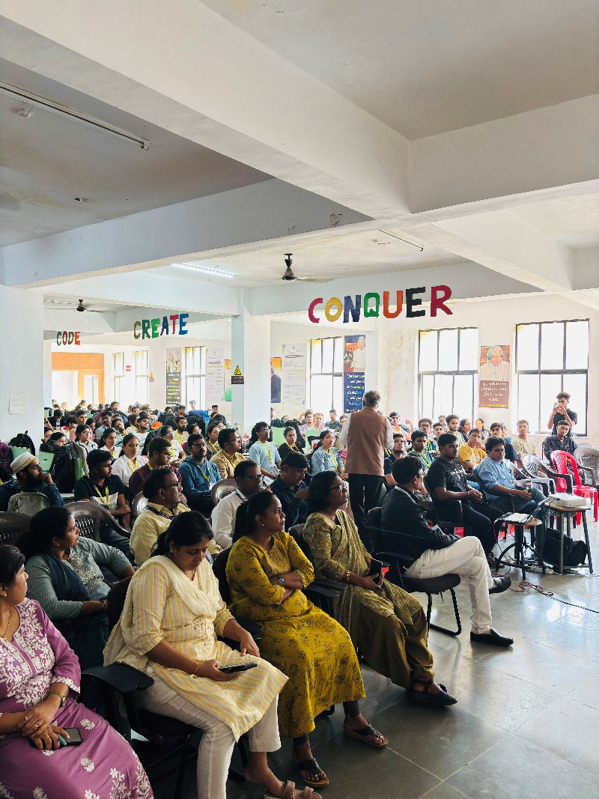

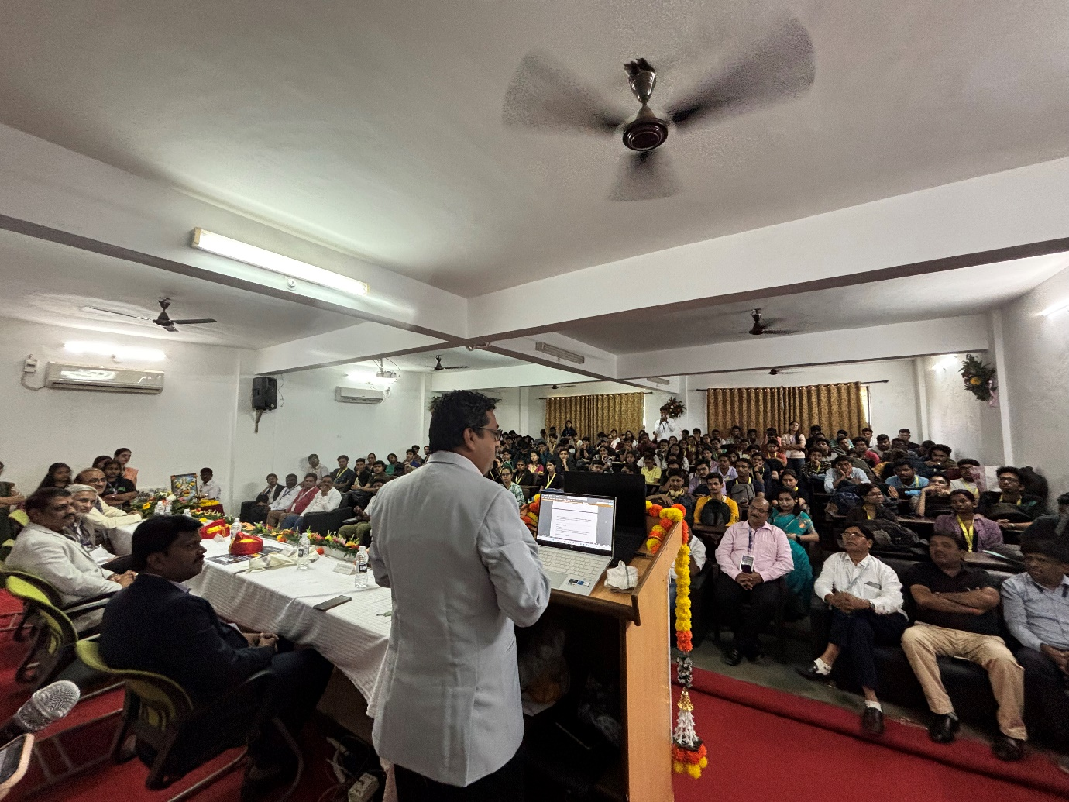

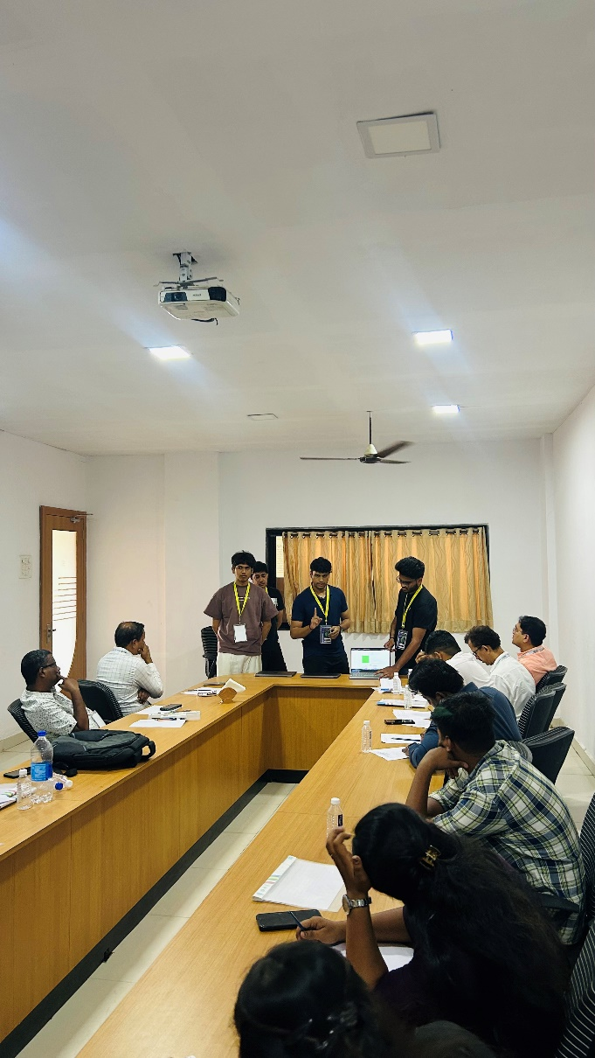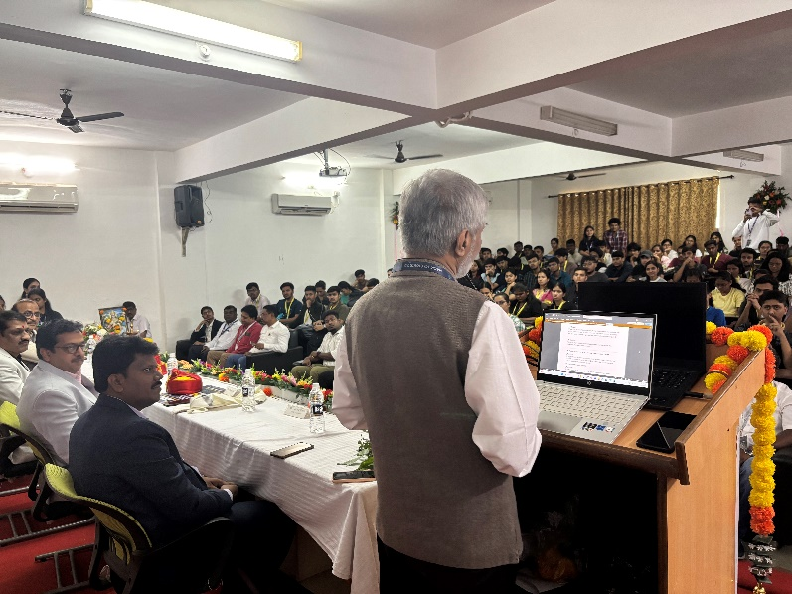

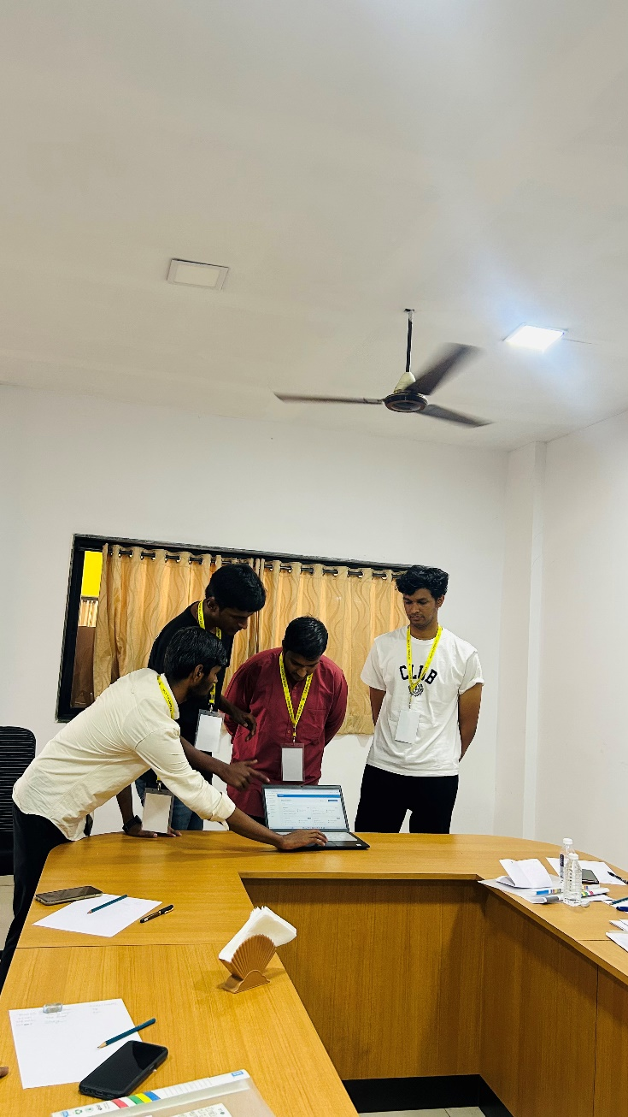

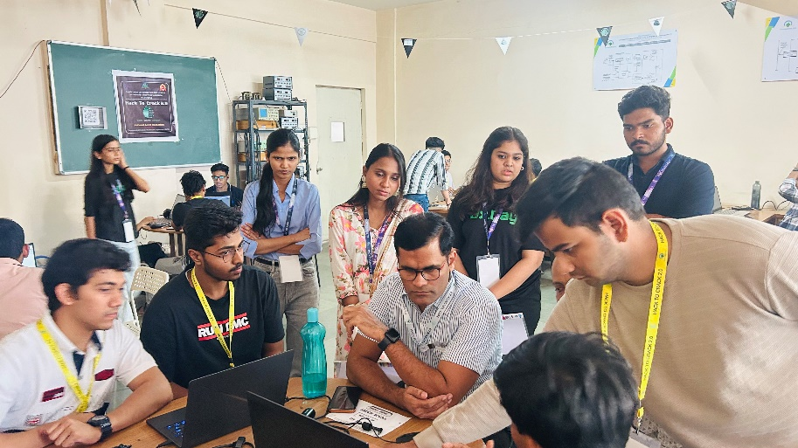

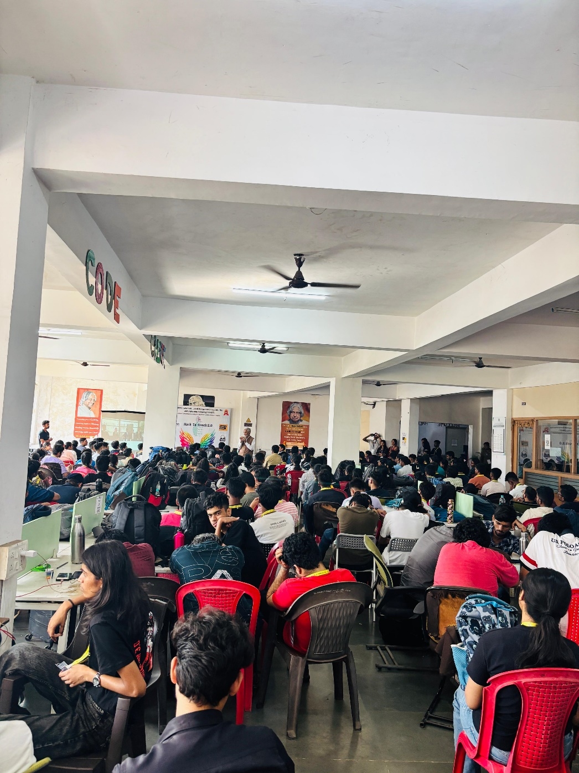

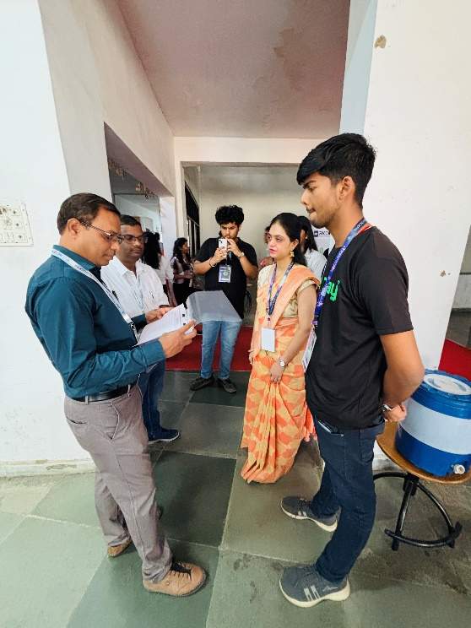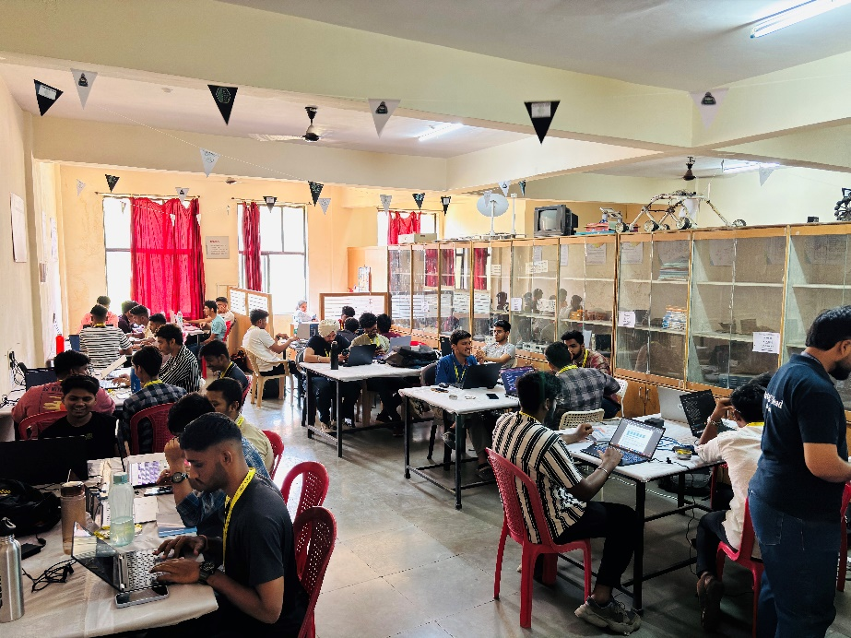

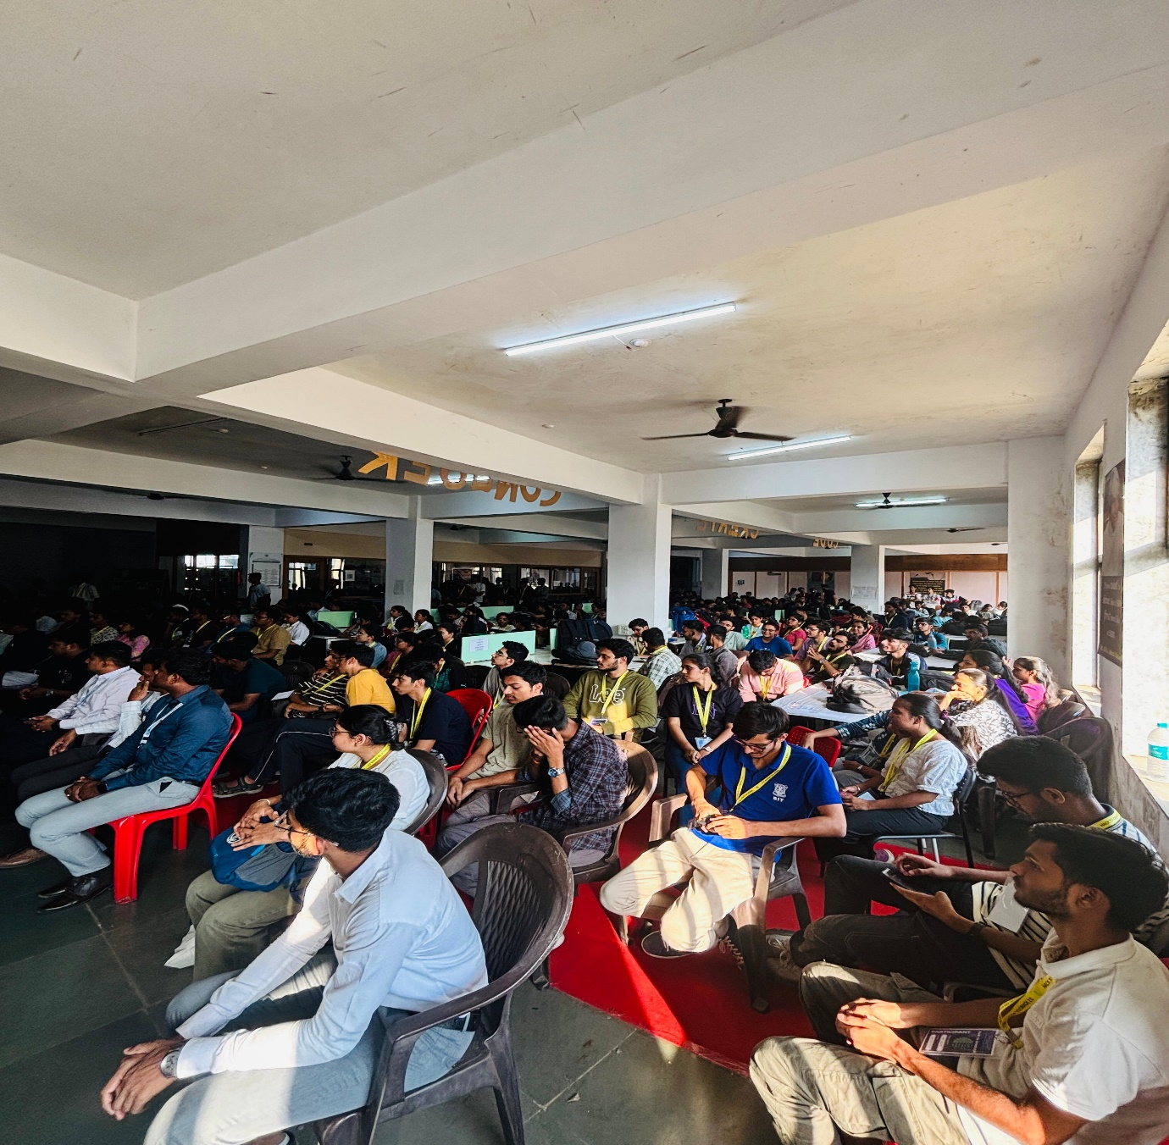

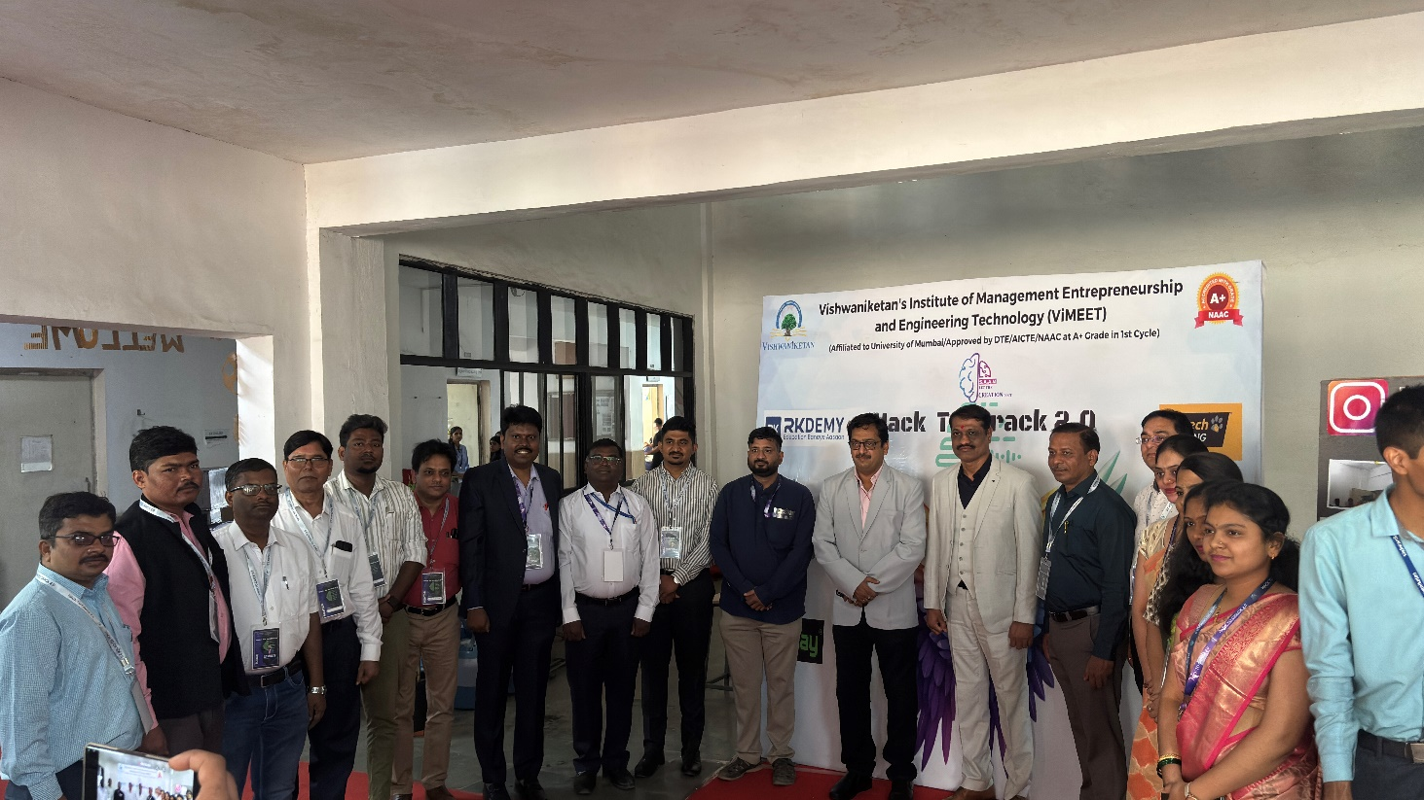

**10. Cultural Event**

The cultural night on March 20, 2025, added a vibrant touch to the hackathon. Participants enjoyed live music, dance performances, and interactive sessions, enhancing the networking experience.

**11. Feedback and Testimonials**

Participants and mentors praised Hack to Crack 2.0 for its well-structured format, problem diversity, and valuable mentorship. Here are a few testimonials:

* *"Hack to Crack was an amazing experience. The mentorship and technical guidance were invaluable."* – Ritik Swaraj, Participant
* *"We were impressed by the quality of ideas presented. The enthusiasm of the students was remarkable."* – Judge

***Social Media Post***

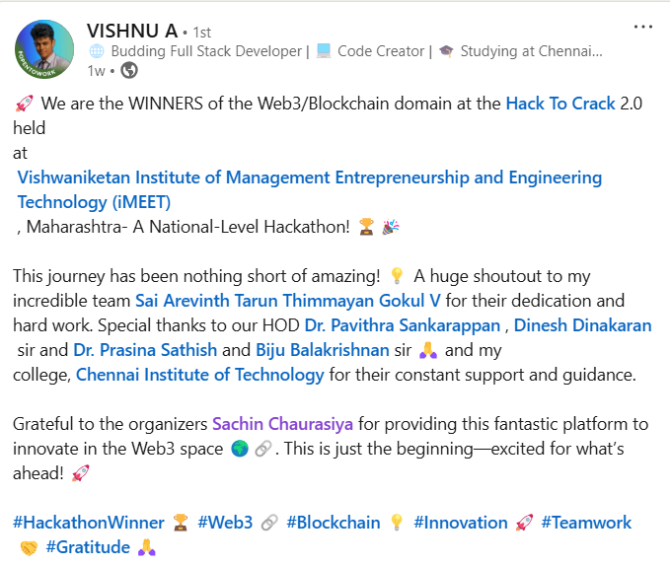

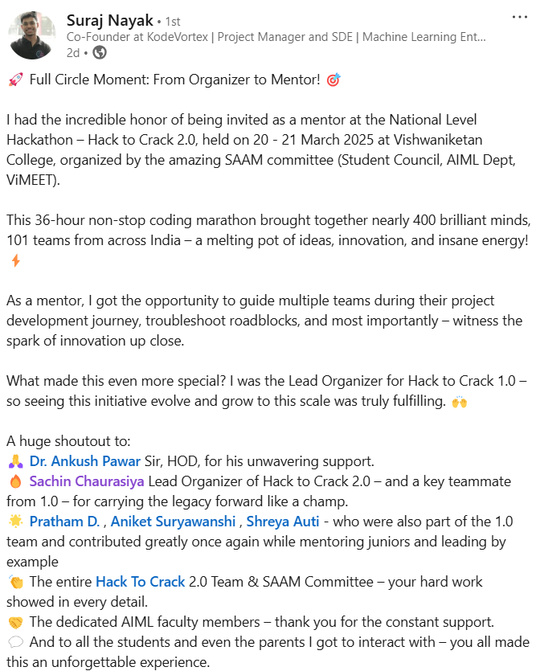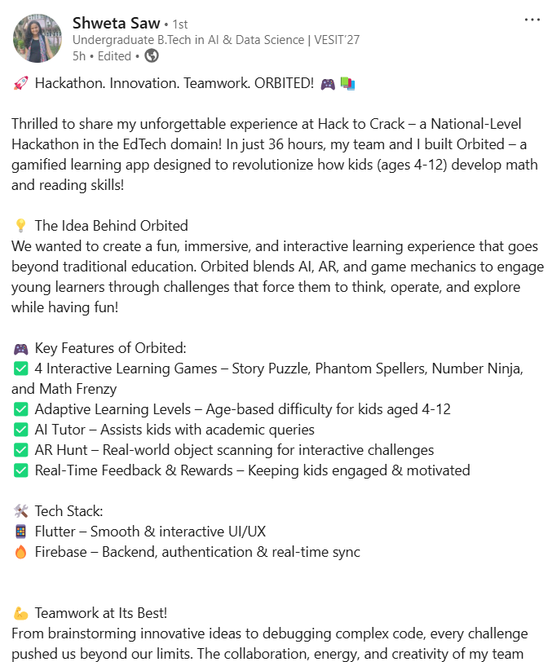

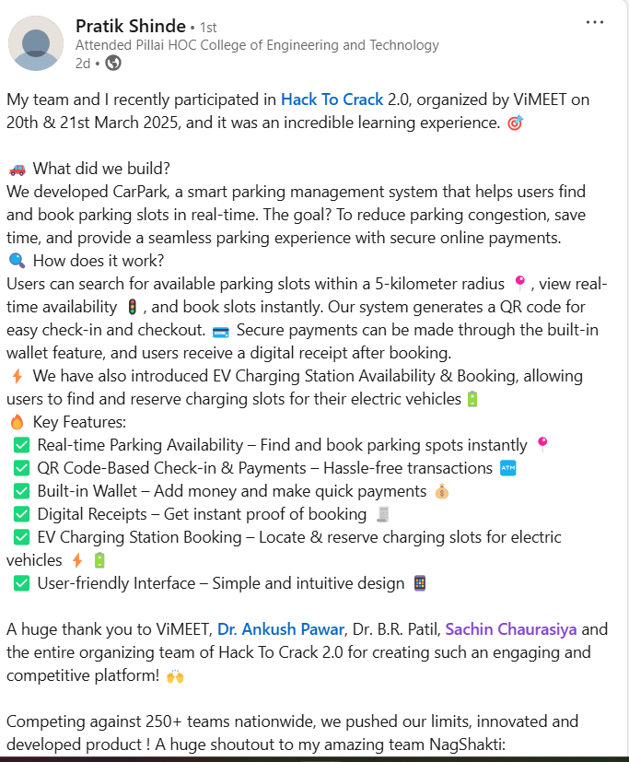

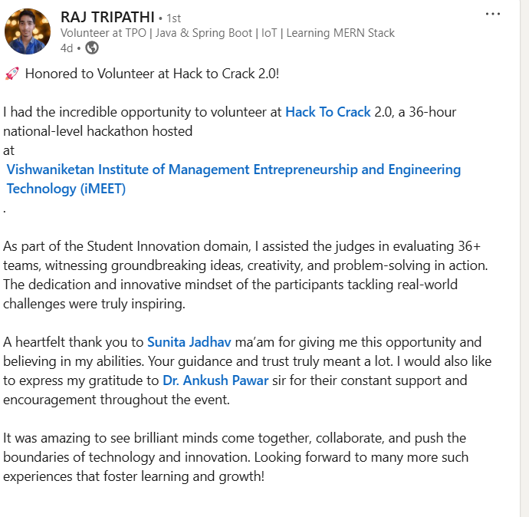

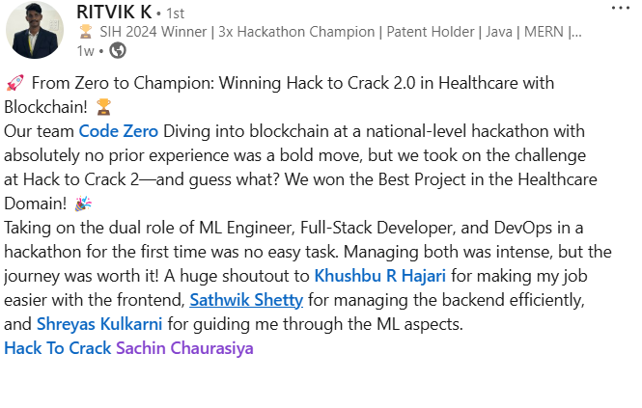

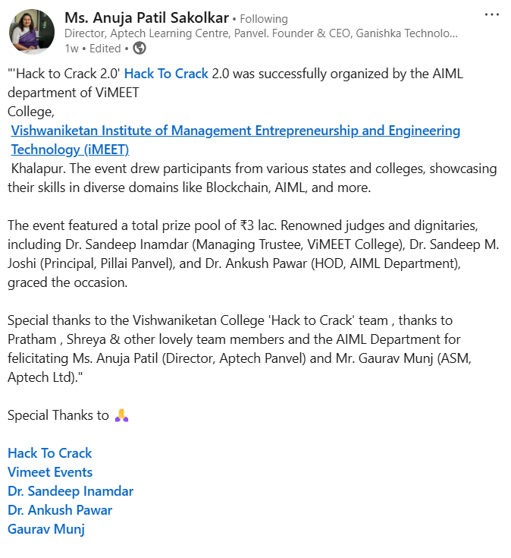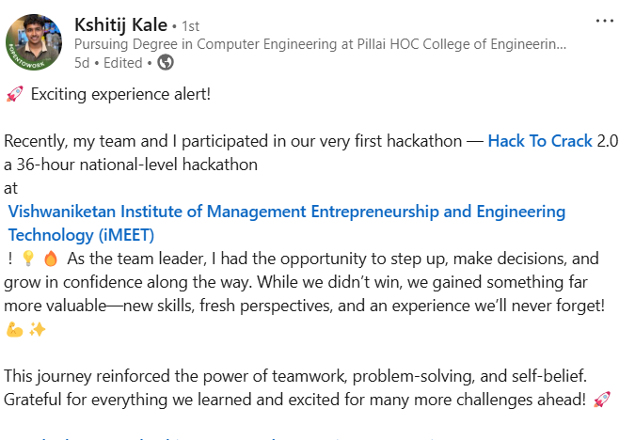

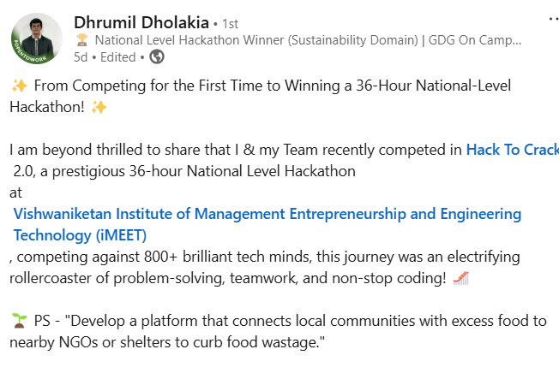

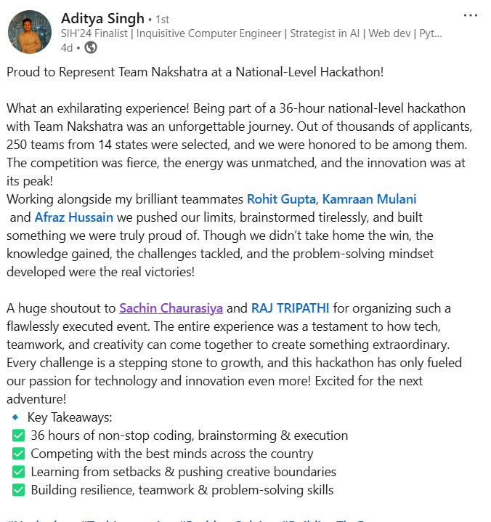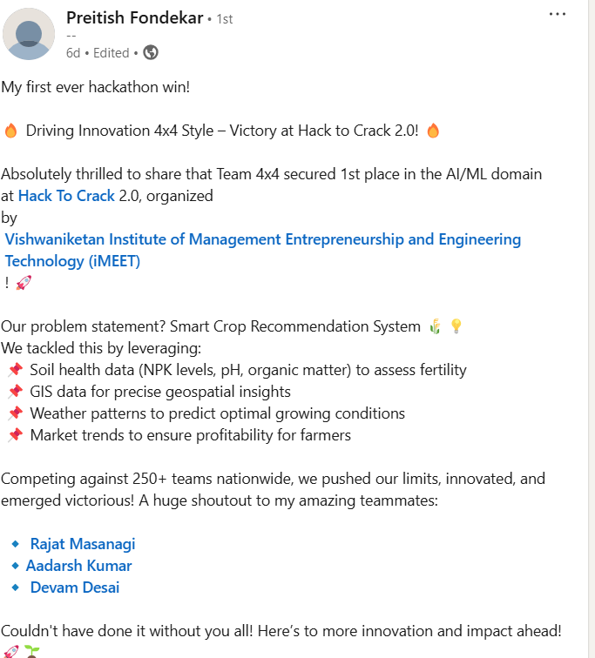

**12. Conclusion**

Hack to Crack 2.0 was a resounding success, providing a platform for innovation and collaboration. The event not only celebrated technological advancements but also fostered connections between students, mentors, and industry leaders.

We extend our heartfelt thanks to all participants, sponsors, mentors, judges, and volunteers who contributed to the event’s success. We look forward to continuing this tradition of innovation and excellence in Hack to Crack 3.0!

Sachin Chaurasiya Dr. Ankush Pawar  
+91 7070416209 +91 99603 33280  
Lead, Hack to Crack 2 Convenor H2C